# Installation manual Python

* Download the latest version from <https://www.python.org/downloads/>
* Double click to run installer
* Check “Add Python to PATH” and click “Customize installation”

* You can uncheck “tcl/tk” (optional, but all other checkboxes need to be on

* Click Next
* Check “Install for all Users”

* Click Install
* Click close

# Installation manual Visual Studio Code

* Download the latest version from <https://code.visualstudio.com/>
* Double click the file
* Accept the agreement and click Next
* Accept the default folder and click Next
* Start menu folder is Ok, click Next
* Additional tasks may be altered, but don’t need to be. Click Next
* Click Install
* VSCode opens
* Click File – new File
* Use Ctrl+S to save the file. Save it as “test.py”
* A pop-up occurs asking to install the recommended extensions

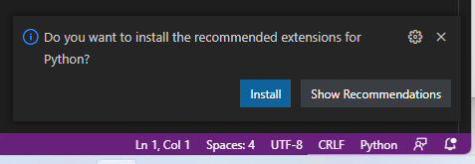

* Click “Install”
* Go back to the file you made (using the tabs)
* Add print(“Hello world”)
* Use the play button (the triangle) on the top right to run the file

* Confirm the output is in the terminal.